# **Pizza Sales SQL Queries**

1. **KPI’s**
2. **Total Revenue:**

SELECT SUM(total_price) AS Total_Revenue FROM pizza_sales;

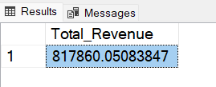

1. **Average Order Value:**

SELECT SUM(total_price) / COUNT(DISTINCT order_id) AS Avg_Order_Value FROM pizza_sales;

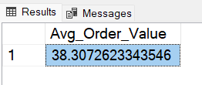

1. **Total Pizza Sold:**

SELECT SUM(quantity) AS Total_Pizza_Sold FROM pizza_sales;

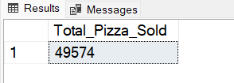

1. **Total Orders:**

SELECT COUNT(Distinct order_id) AS Total_Orders FROM pizza_sales;

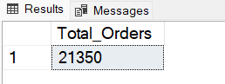

1. **Average Pizzas Per Order:**

SELECT

CAST(

CAST(SUM(quantity) AS DECIMAL (10, 2)) / CAST(COUNT(DISTINCT order_id) AS DECIMAL (10, 2)

) AS DECIMAL (10, 2)) AS Avg_Pizzas_Per_Order

FROM pizza_sales;

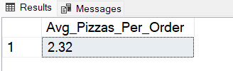

1. **Daily Trend for Total Orders:**

SELECT

DATENAME(DW, order_date) AS Order_Day, COUNT(DISTINCT order_id) AS Total_Orders

FROM pizza_sales

GROUP BY DATENAME(DW, order_date)

ORDER BY COUNT(DISTINCT order_id) DESC;

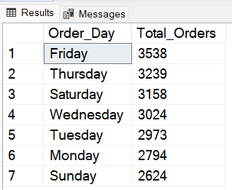

1. **Monthly Trend for Total Orders:**

SELECT

DATENAME(MONTH, order_date) AS Order_Day, COUNT(DISTINCT order_id) AS Total_Orders

FROM pizza_sales

GROUP BY DATENAME(MONTH, order_date)

ORDER BY COUNT(DISTINCT order_id) DESC;

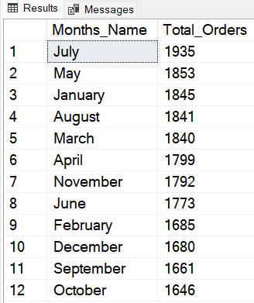

1. **Percentage of Sales by Pizza Category:**

SELECT

pizza_category, SUM(total_price) AS Total_Sales,

CAST(SUM(total_price) * 100.0 / (

SELECT SUM(total_price) FROM pizza_sales

) AS DECIMAL(10, 2)

) AS PCT

FROM pizza_sales

GROUP BY pizza_category;

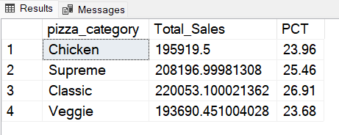

1. **Percentage of Saley by Pizza Size:**

SELECT

pizza_size, SUM(total_price) AS Total_Sales,

CAST(SUM(total_price) * 100.0 / (

SELECT SUM(total_price) FROM pizza_sales

) AS DECIMAL(10, 2)

) AS PCT

FROM pizza_sales

GROUP BY pizza_size

ORDER BY PCT DESC**;**

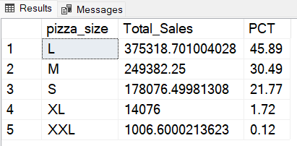

1. **Top 5 Pizzas by Total Revenue**

SELECT

TOP 5 pizza_name,

SUM(total_price) AS Total_Revenue

FROM pizza_sales

GROUP BY pizza_name

ORDER BY Total_Revenue DESC;

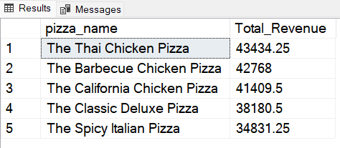

1. **Bottom 5 Pizzas by Total Revenue**

SELECT

TOP 5 pizza_name,

SUM(total_price) AS Total_Revenue

FROM pizza_sales

GROUP BY pizza_name

ORDER BY Total_Revenue ASC;

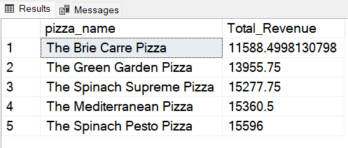

1. **Top 5 Pizzas by Total Quantity**

SELECT

TOP 5 pizza_name,

SUM(quantity) AS Total_Quantity

FROM pizza_sales

GROUP BY pizza_name

ORDER BY Total_Quantity DESC;

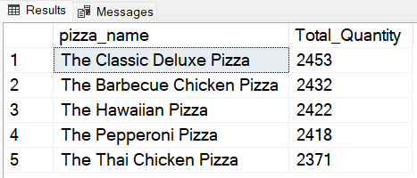

1. **Bottom 5 Pizzas by Quantity**

SELECT

TOP 5 pizza_name,

SUM(quantity) AS Total_Quantity

FROM pizza_sales

GROUP BY pizza_name

ORDER BY Total_Quantity ASC;

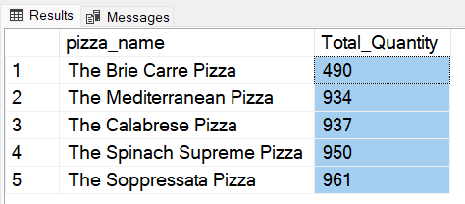

1. **Top 5 Pizzas by Total Orders**

SELECT

TOP 5 pizza_name,

COUNT(DISTINCT order_id) AS Total_Orders

FROM pizza_sales

GROUP BY pizza_name

ORDER BY Total_Orders DESC;

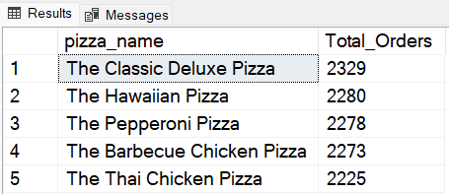

1. **Bottom 5 Pizzas by Total Orders**

SELECT

TOP 5 pizza_name,

COUNT(DISTINCT order_id) AS Total_Orders

FROM pizza_sales

GROUP BY pizza_name

ORDER BY Total_Orders ASC;

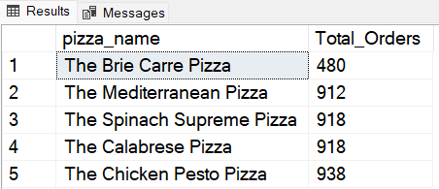

**NOTE**

1. **Percentage of Total Sales by Category On January**

**SELECT**

**pizza_category, SUM(total_price) AS Total_Sales,**

**CAST(SUM(total_price) * 100.0 / (**

**SELECT SUM(total_price)**

**FROM pizza_sales**

**WHERE MONTH(order_date) = 1**

**) AS DECIMAL(10, 2)**

**) AS PCT**

**FROM pizza_sales**

**WHERE MONTH(order_date) = 1**

**GROUP BY pizza_category;**

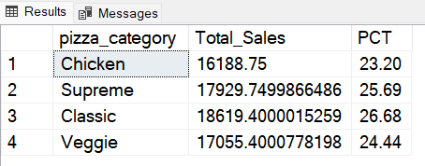

1. **Percentage of Total Sales by Category On 1st Quarter**

**SELECT**

**pizza_category, SUM(total_price) AS Total_Sales,**

**CAST(SUM(total_price) * 100.0 / (**

**SELECT SUM(total_price)**

**FROM pizza_sales**

**WHERE DETAPART(QUARTER, order_date) = 1**

**) AS DECIMAL(10, 2)**

**) AS PCT**

**FROM pizza_sales**

**WHERE DETAPART(QUARTER, order_date) = 1**

**GROUP BY pizza_category;**

